Falcon Subsystem

Co-Panel

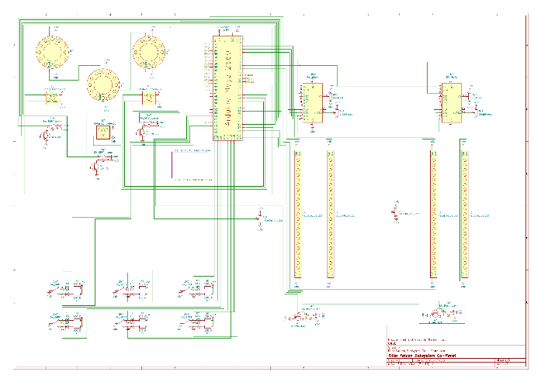

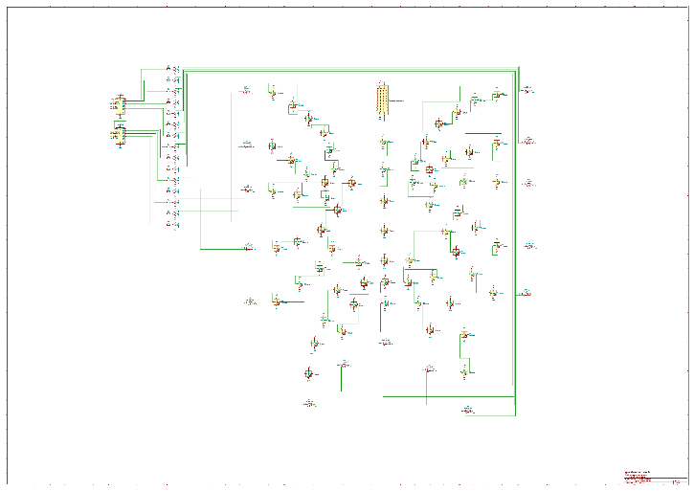

# Table Of Contents

* Engines
* Fuel Injectors
* Inductors
* Switches / Shift Registers

Engines

These 3 disks of Neo Pixels are supposed to represent the 3 engines on board the falcon. (if you notice I am actually using correct names for most of this stuff on the falcon, this is because it was the last to go in so I could actually read what everything was while I was programming) Depending on the speed of the wheel spin shows how fast the fuel is being consumed.

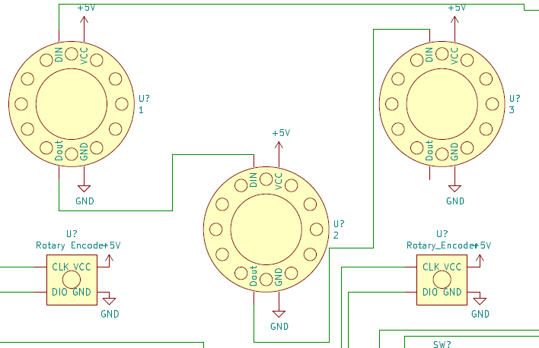

1. Neo Pixel Rings – These are the feedback portion for the user, they spin fast, slow, or even not at all if turned off. They are daisy chained from left to right, viewing from the back. They are also all need 5v and GND, the Din pin on the first ring comes from pin 10 on the Arduino.
2. 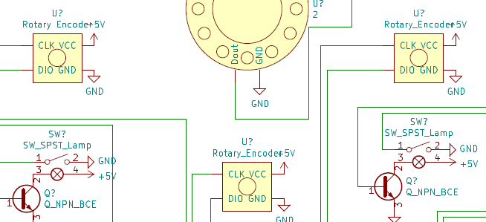Rotary Encoders – These are what the user twists to adjust the speed of fuel consumption, they need 5v, GND, and 2 pins on the Arduino (Shown below). If it is twisting the opposite way that you want or need, then just swap CLK and DIO.

|  |  |  |
| --- | --- | --- |
| **Encoder** | **CLK Pin** | **DIO Pin** |
| Left | 14 | 15 |
| Middle | 16 | 17 |
| Right | 18 | 19 |

|  |  |  |
| --- | --- | --- |
| **Switch** | **Button Pin** | **Transistor Pin** |
| Left | 22 | 25 |
| Middle | 23 | 26 |
| Right | 24 | 27 |

1. 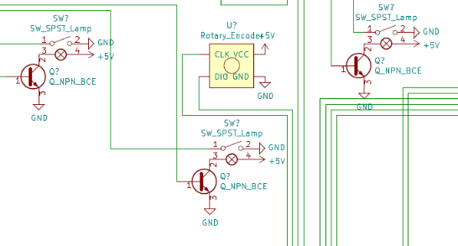Power Buttons – If the user wants to disable an engine, all they must do is click its power button, it is lit up when the engine is on, and off If the engine is off, if the engine is off the circle will stop rotating. These are non-latching SPST (SPDT compatible) light up switches. The switch com is hooked to ground and the other side to the Arduino, on the lamp it is hooked to 5v, and on the other side an NPN transistor hooked to ground controlled by a pin on the Arduino.

Fuel Injectors

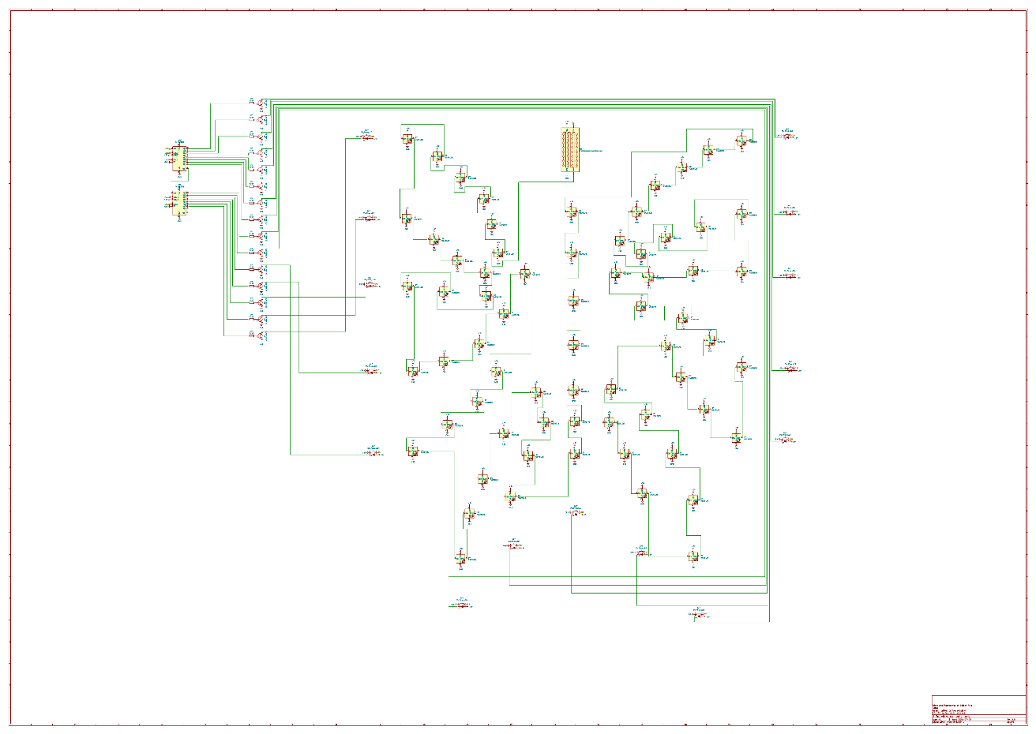

This is my favorite part of this panel, the fuel injectors, you can see the fuel lines and add additives to the fuel to make it burn better, stronger, or more efficiently. This was hard to wire (mostly because of Neo Pixels), which is why it got its whole own page on the schematic. (schematic to the right is a view from the back of the panel)

1. Neo Pixels – This is what represents the fuel line and buffer, lots of colors representing all the additives, it is a bit hard to explain the whole path to this, so you will have to look at page 2 on the schematic to get an explanation of that, but 2 quick things I will say is that they all require 5v and GND (big surprise) and pixel 0 gets their data from pin A2 on the Arduino.
2. Switches – These are also no piece of cake to wire, they are all SPST light up pushbuttons. The button portions have one pin to GND and the other to a pin on the Arduino. The lights get 5v (put a resistor if yours needs it, the first version is wired slightly differently and thus doesn’t need one) and then uses an NPN transistor hooked to ground controlled by a shift register port. I don’t remember exactly but I believe the original panel uses the shift register out for power on the button light and then it is just grounded, but this may reduce life of the panel, and if it must be replaced down the line, just slap some transistors in, or just replace the chips, I put dip sockets in there for you :D. The table below is ordered counterclockwise from the top right button.

|  |  |  |
| --- | --- | --- |
| **Button Position (schematic view is back of panel)** | **Arduino Switch Pin** | **Shift Register Light Pin** |
| Right Top | 32 | Register 1 Qa |
| Right Upper Middle | 33 | Register 1 Qb |
| Right Middle | 34 | Register 1 Qc |
| Right Lower Middle | 35 | Register 1 Qd |
| Right Bottom | 36 | Register 1 Qe |
| Bottom Right | 37 | Register 1 Qf |
| Bottom Middle Right | 38 | Register 1 Qg |
| Bottom Middle | 39 | Register 1 Qh |
| Bottom Middle Left | 40 | Register 2 Qa |
| Bottom Left | 41 | Register 2 Qb |
| Left Bottom | 42 | Register 2 Qc |
| Left Lower Middle | 43 | Register 2 Qd |
| Left Middle | 44 | Register 2 Qe |
| Left Upper Middle | 45 | Register 2 Qf |
| Left Top | 46 | Register 2 Qg |

Inductors

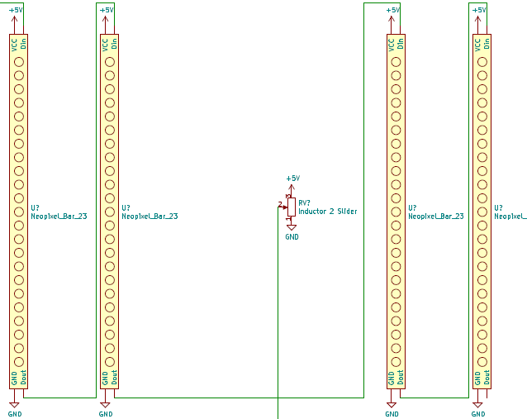 These are the bar graphs on the bottom right of the panel, depending on the slider position, the graph will light up, It also displays the percent on at the top with the LCD character display, lastly you can turn on or off the inductors with the buttons on the bottom of them.

1. Neo Pixels – These are daisy chained, bottom up, and all require 5v and GND, the first graph needs Din from pin 9 on the Arduino.
2. 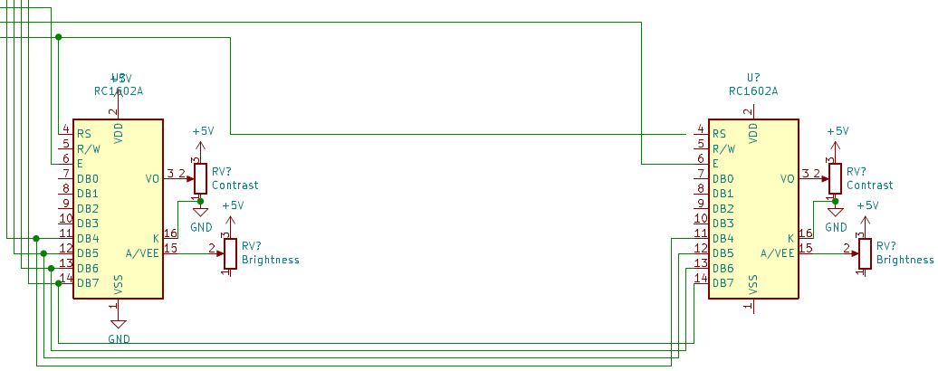 LCD Displays - these tell the user more exact data from the bar graphs, giving percents in 5% increments. These are also a bit intereting to wire, but not too bad. Their A pin goes through either a resistor or potenetiometer to 5v, K goes to GND, Contrast goes through a potentiometer pulling from 5v and GND, VCC goes to 5v and finally GND goes to GND. Now please note that V0 is treated as the contrast pin on the schematic, that is not so, that is just because of the symbol they have on kicad, but it is pin 3 on the lcd (ki cad labels it V0, but it is actually contrast).

|  |  |  |
| --- | --- | --- |
| **Screen Pin** | **Screen 1 Pin Arduino** | **Screen 2 Pin Arduino** |
| RS | 8 | 8 |
| E | 6 | 7 |
| D4 | 5 | 5 |
| D5 | 4 | 4 |
| D6 | 3 | 3 |
| D7 | 2 | 2 |

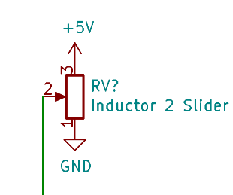

1. 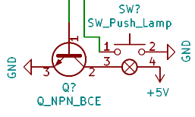Potentiometer Sliders – These are what controls at what percent each side is at. They have either side hooked to 5v and GND, then the com port goes to pin A0, side 1, or pin A1, side 2, on the Arduino.
2. Power Buttons – These turn the sliders either on or off, they are SPST non latching light up buttons. One side of the button Is hooked to GND, and the other to either Pin 28, side 1, or Pin 29, side 2, on the Arduino. The Light is hooked to 5v and an NPN transistor hooked to GND, controlled by a pin on the Arduino, Pin 30 for side 1, pin 31 for side 2.

Switches / Shift Registers

1. 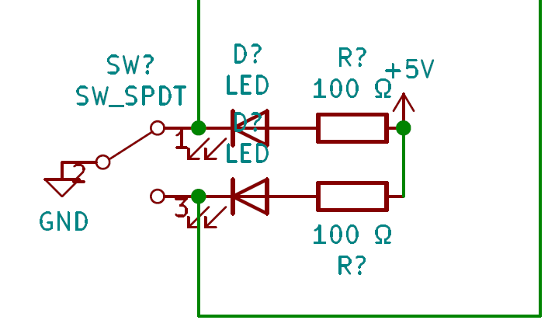Switches - SPDT toggle switches that either show the left light, the right light, or no light (they can stay in the middle, they have 3 positions). These are not hooked up to the Arduino yet on the physical panel, because they don’t need to interact with it to talk to thorium yet, but I have reserved pins for them. They are super easy to wire, the best way to explain them is to just look at them. Here is how they are planned to hook to the microcontroller though:

|  |  |  |
| --- | --- | --- |
| Switch Position | Left Side Arduino Pin | Right Side Arduino Pin |
| Top Left | A3 | A4 |
| Top Middle | A5 | A6 |
| Top Right | A7 | A8 |
| Bottom Left | A9 | A10 |
| Bottom Middle | A11 | A12 |
| Bottom Right | A13 | A14 |

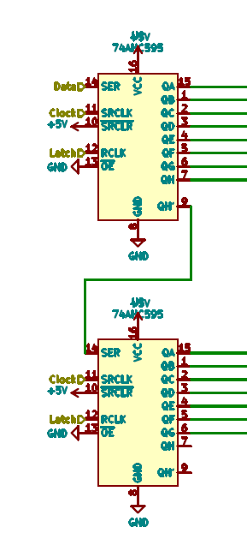

1. Shift Registers: They are wired accordingly:

|  |  |
| --- | --- |
| **Shift Register Pin** | **Arduino Pin / Power** |
| SER (14) | 11 |
| Clock (11) | 12 |
| RCLK (12) | 13 |
| VCC (16) | 5V |
| SRCLR (10) | 5V |
| GND (8) | GND |
| OE (13) | GND |

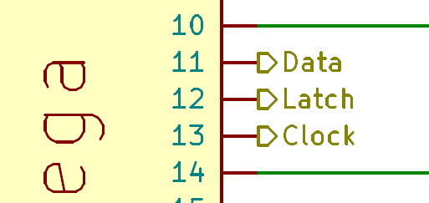With Qa -Qh wired to the output they are needed for (Please refer to Fuel Injectors for more information)